

USER GUIDE

Positive Pay

Revision 0.1

Table of Contents

Revision History 3

User Guide for Positive Pay 4

Steps to run SSIS package for Positive Pay: 4

# Revision History

|  |  |  |  |  |  |  |
| --- | --- | --- | --- | --- | --- | --- |
| S.N | Author | Description | Revision | Date | Reviewed by | Comments |
| 1 | Jeevan Timilsina | User Guide for Positive Pay | 0.1 | 29/07/2011 | Sanket Shrestha |  |
| 2 | Jeevan Timilsina | Modification | 0.2 | 26/08/2011 | Sanket Shrestha |  |
|  |  |  |  |  |  |  |

# User Guide for Positive Pay

It is important to have all the necessary elements before executing the dtsx package of Positive Pay. In case of POSITIVE PAY, we will need to execute sql file named ‘OutboundScriptPositivePayFinal.sql’ and ForFirstProcessing.sql with Sql Server Management Studio.

**NOTE:** *The script "ForFirstProcessing.sql"is to be run only once for the very first processing only.  
-Check SELECT * FROM [Temp_TBL_PositivePay]  
-Do not run this script if the table Temp_TBL_PositivePay already exists and there is already an entry MAX_ACCOUNT_KEY=0*

The next step is to run the dtsx package. It is as mentioned below.

## Steps to run SSIS package for Positive Pay:

1. Right click on the package and select edit.
2. This will give an error screen , this can be ignored by clicking ok.
3. This provides the screen as mentioned below.

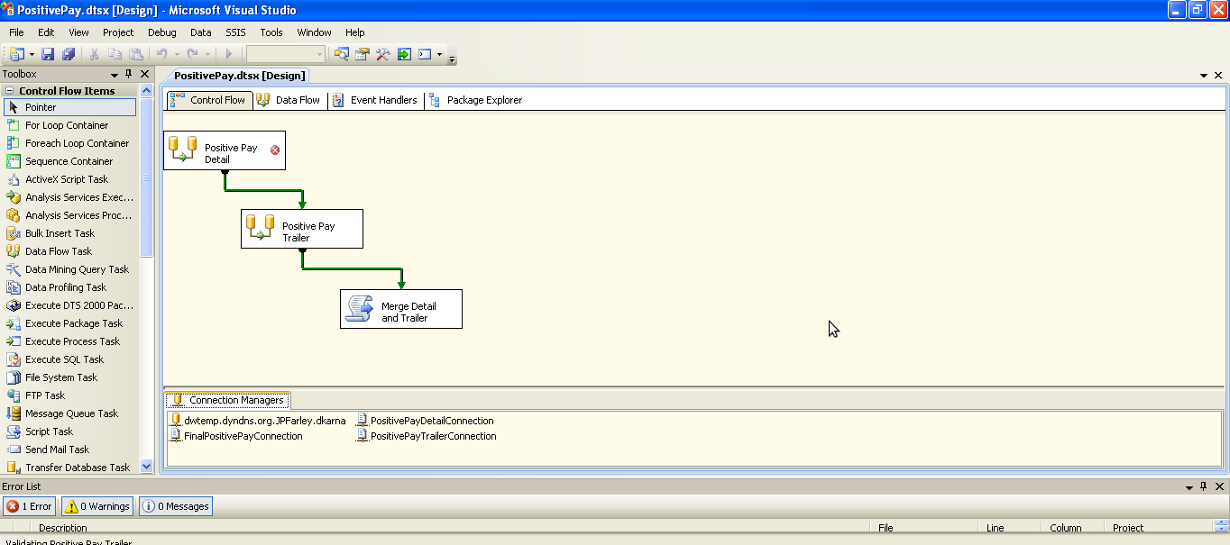

1. This is in control flow pane. All the 4 components shown in the pane are individual data flow components which needs to be configured after configuring the connections.
2. Double click on the database connection named “PositivePayDetailConnection” which will provide a screen as mentioned below.

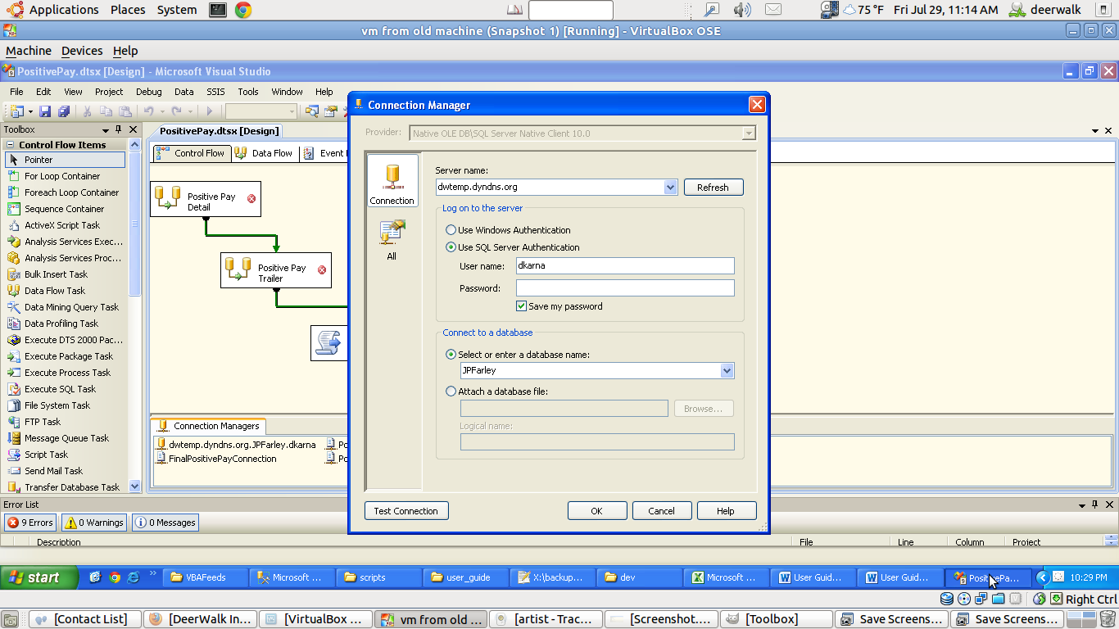

1. Provide the appropriate connection parameters like server name, credentials as well as the database name and click on ok button.
2. Now, double click on “PositivePayDetailConnection” or any one of other file connections under Connection Managers.A new window gets displayed as show below.

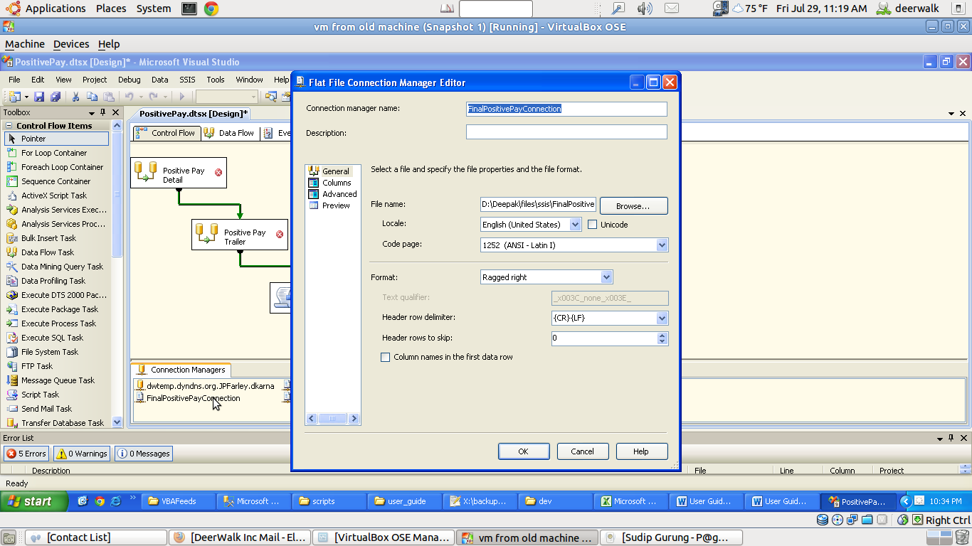

1. Click on browse and give the path with the appropriate file name where the resultant file has to be dumped.
2. Click on the Advanced option. For every column displayed, choose the False menu from the dropdown list in TextQualified field. The screenshot for this is as below: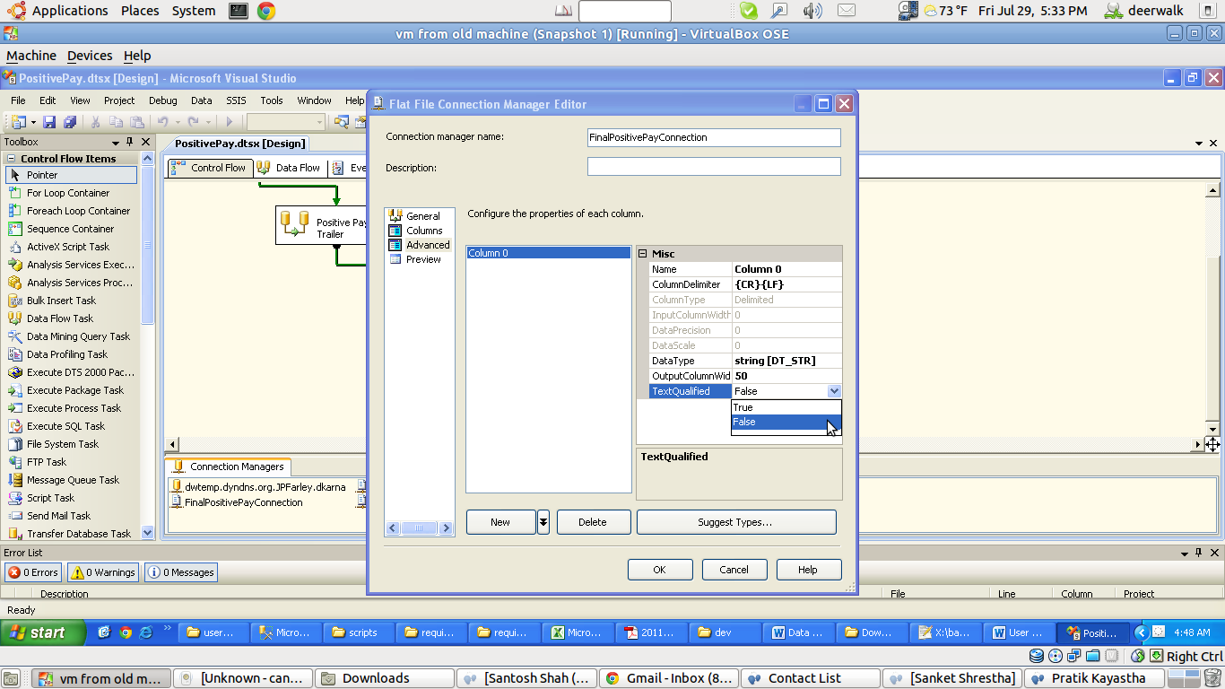

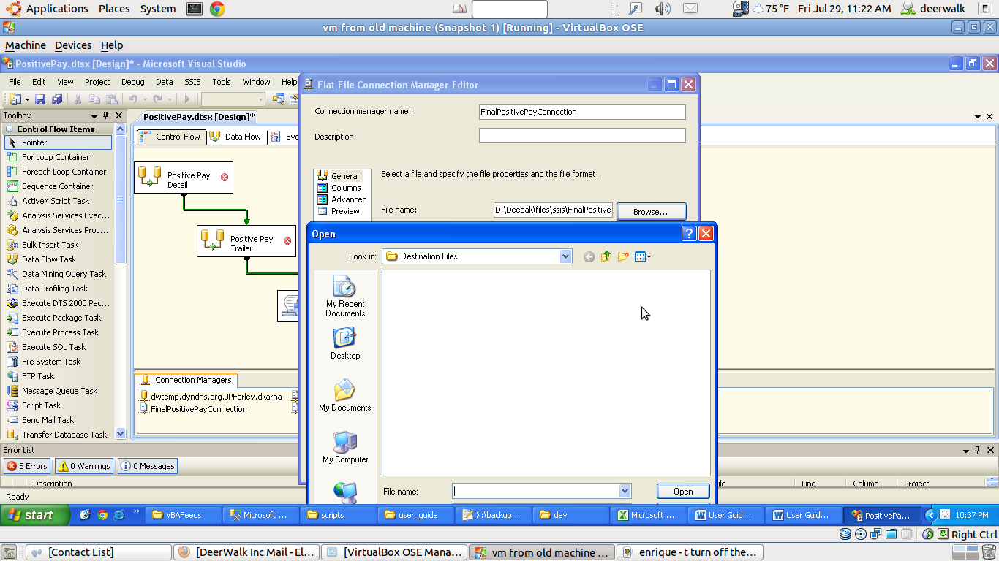

1. Select “TXT file (*.txt)” option from the drop down on another side of the screen and click on open option. Click OK for the next two windows.

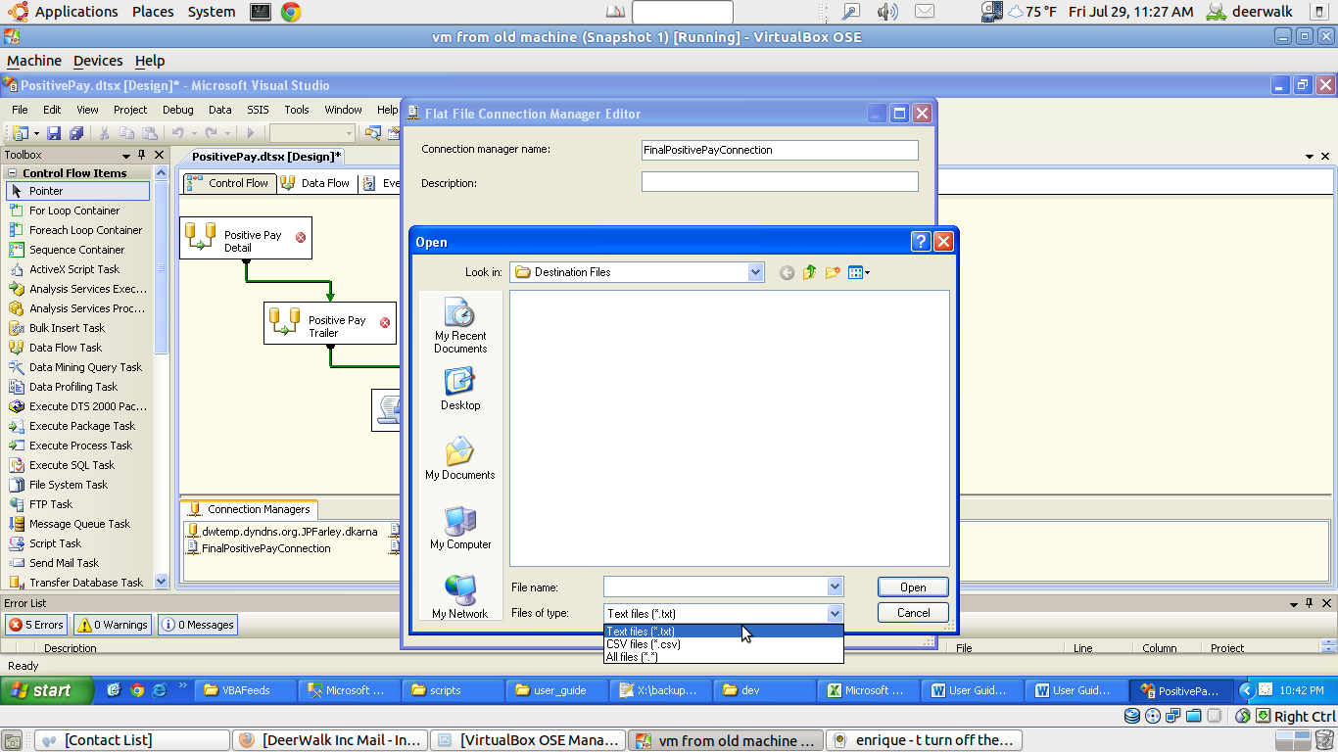

1. Now on the Control Flow, double click on Positive Pay Detail component. This will direct us to Data Flow with the window shown as below: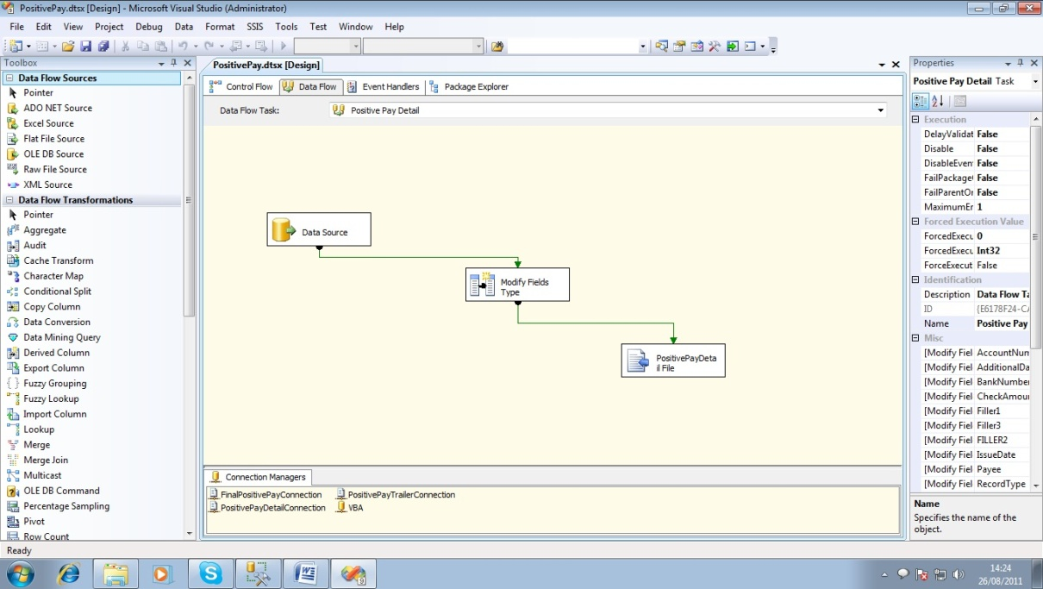
2. Now double click on the data Source and click on the Columns option in the left corner of the new window displayed. Then click OK.

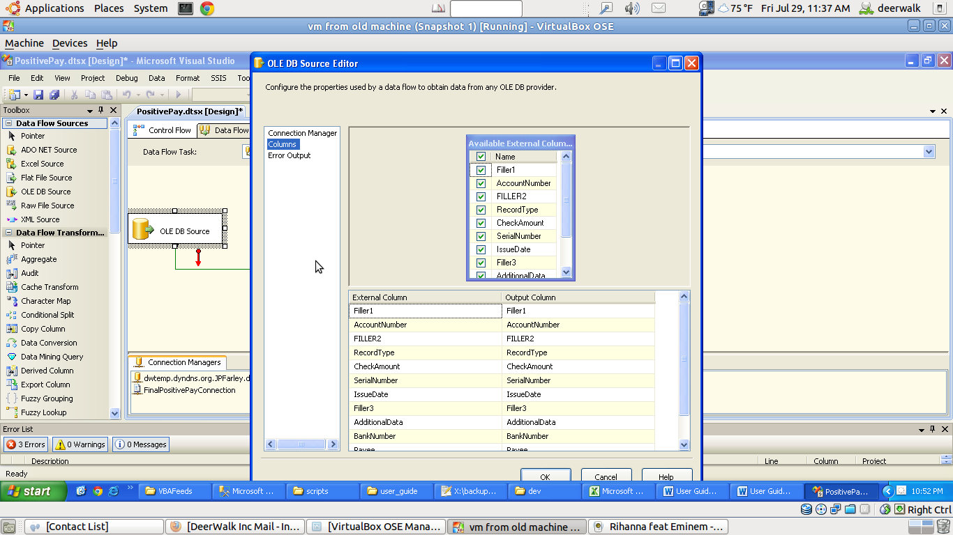

1. Again go to Data Flow and double click PositivePayDetail File which will display the following window.

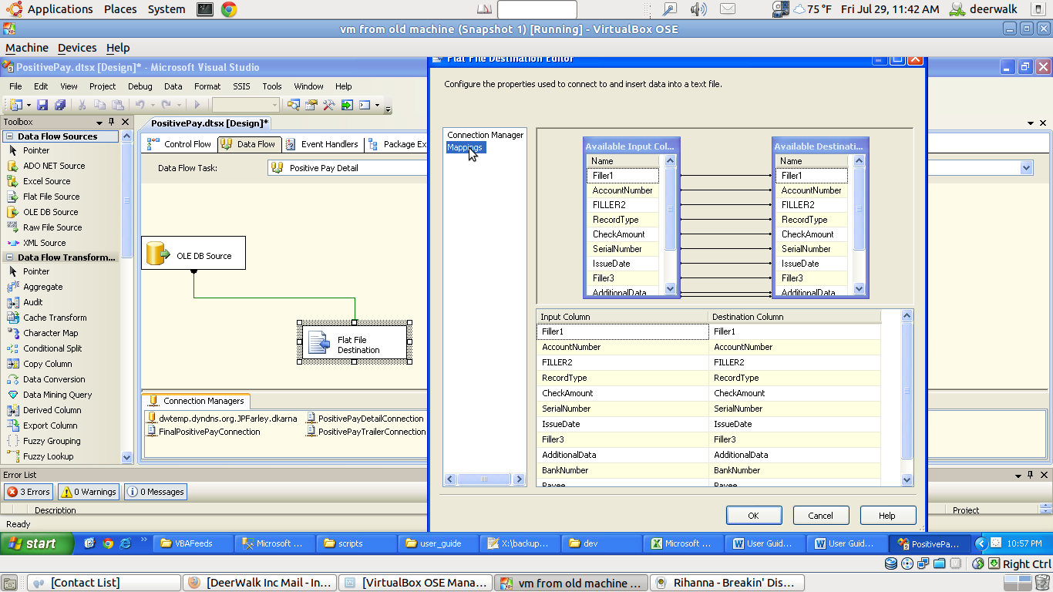

1. Click on Mappings option. This will show the one to one mapping of the Input and the destination. Then click On OK.
2. Do the similar task for the component “Positive Pay Trailer” in the Control Flow. Repeat the process from 12 to 15.
3. Finally save the dtsx package by clicking on save option in the editor and close the BIDs interface.
4. Now go to the folder containing the respective dtsxpakage.
5. Directly double click on the dtsx package to run it. When we double click on the package, we will get the window as shown below.

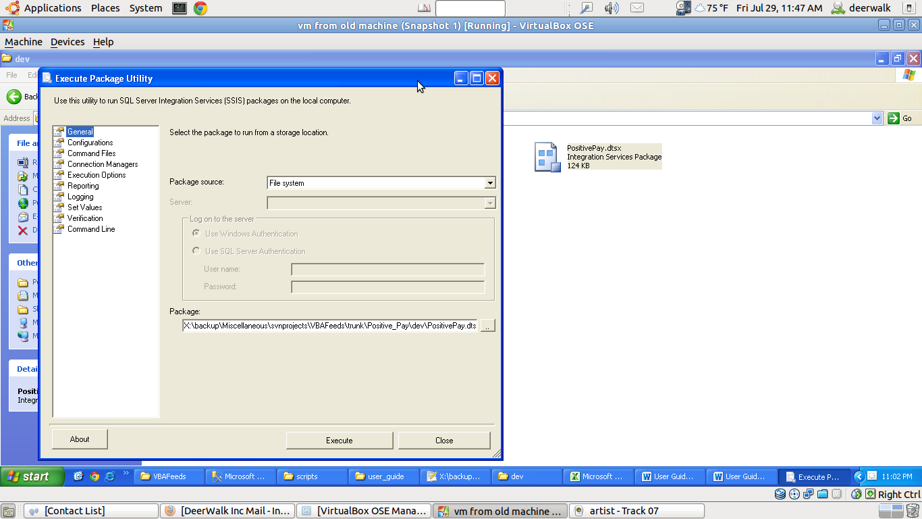

1. Now, directly click on the execute button and get the package executed. The executing window you get is as mentioned below.

